**Supplementary Information**

**TITLE**: Throughfall, stemflow and interception loss in *Grewia optiva* and *Morus alba* in north west Himalayas

**AUTHORS**: Akram Ahmed, J. M. S. Tomar, H. Mehta, R. Kaushal, Dibyendu Deb & O. P. Chaturvedi, P. K. Mishra

**Fig. S1:** Stemflow collection system.

**Fig. S2:** Digitized branch (a, b) and leaf (c, d) orientation in *G. optiva* and *M. alba, respectively.*

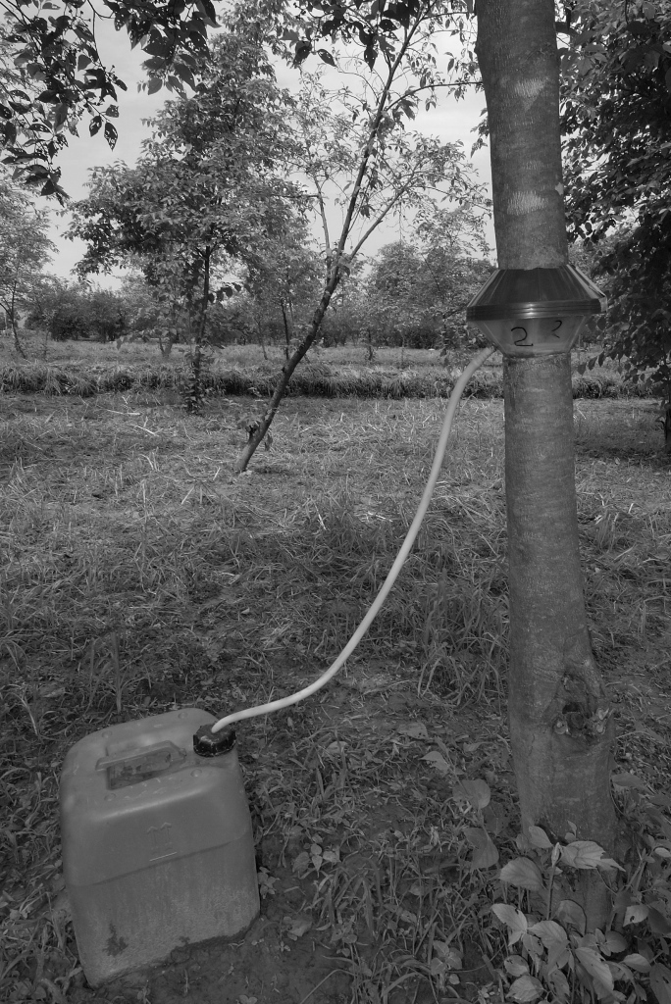

**Fig. S1:** Stemflow collection system.

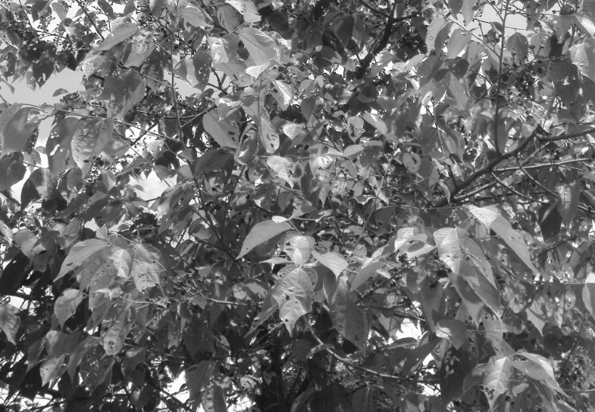

c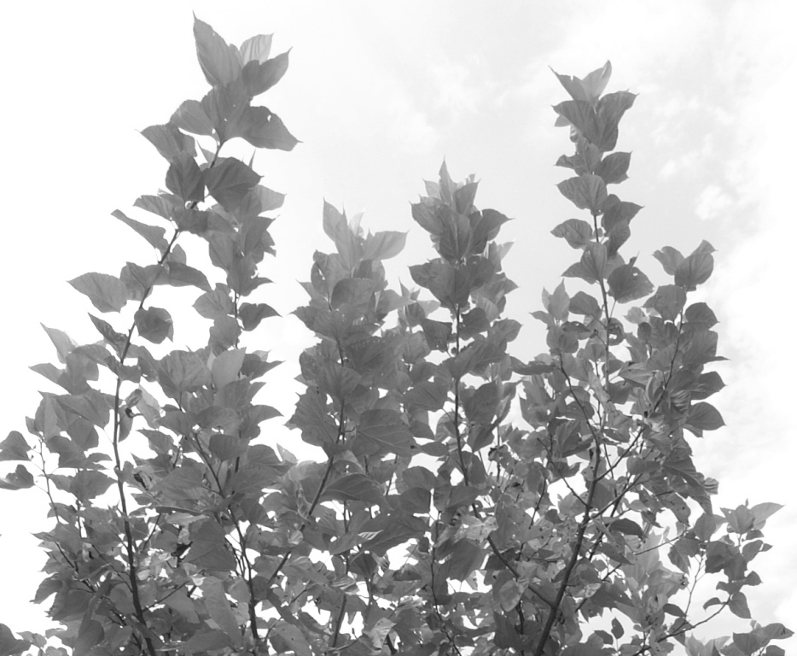

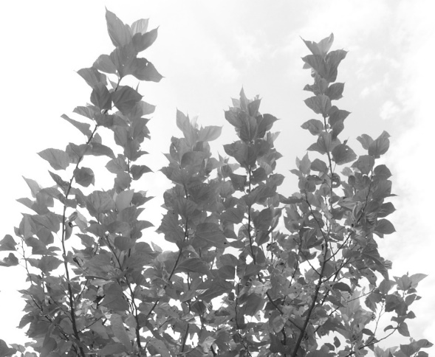

d

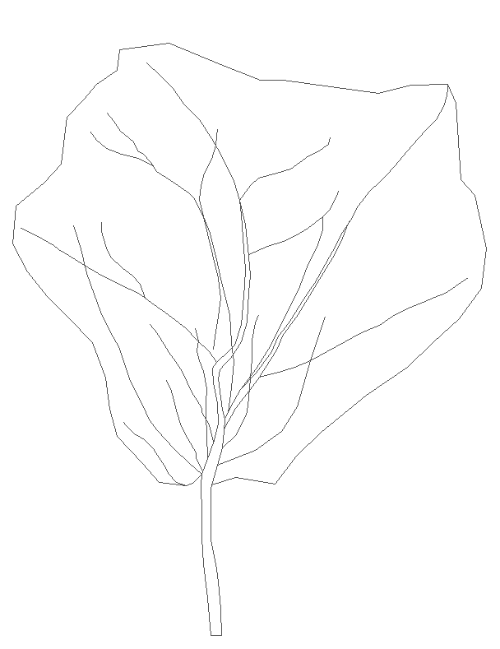

b

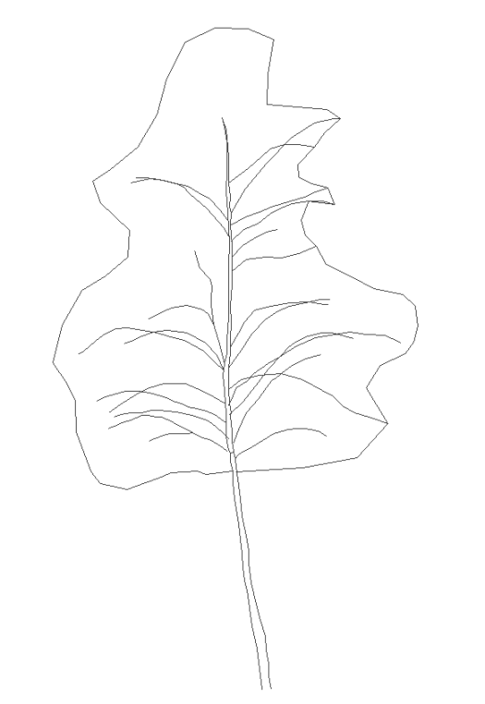

a

**Fig. S2:** Digitized branch (a, b) and leaf (c, d) orientation in *G. optiva* and *M. alba, respectively.*